ASSIGNMENT OFFER LETTER

Punta del Este, Uruguay, December 21, 2023

**Spreedly, Inc.**

**300 Morris Street**

**Suite 400**

**Durham NC 27701**

**United States**

Irrevocable A. Offer letter Nº 20231221 Spreedly

Dear Sirs,

We hereby extend our irrevocable offer to purchase the Receivables, as defined in Annex 1 hereto, and according to the terms of such Annex 1.

Our offer remains valid for the next five (5) business days from the date herein and shall constitute a binding agreement between the parties upon our receipt of your acceptance letter.

Regards,

Blasaca SAS

By: Name: Sebastian Caputo

Title: Attorney in fact

Annex 1

# ASSIGNMENT AGREEMENT

THIS ASSIGNMENT AGREEMENT (the “Agreement”) made and entered into in December 21, 2023 (the “Effective Date”), by and between Blasaca SAS, a corporation duly incorporated in the Republic of Uruguay (“Buyer”); and **Spreedly, Inc**, a corporation duly incorporated in the United States, a Delaware corporation (the “Assignor”);

# RECITALS

1. Whereas Assignor desires to sell and assign to Buyer certain Receivables (as defined below); and

1. Whereas Buyer desires to purchase the Receivables, which Buyer in its sole discretion deems acceptable for purchase, according to the terms and conditions provided in this Agreement.

In consideration of the above recitals and mutual covenants herein contained and for other good and valuable consideration, the receipt and sufficiency of which are hereby acknowledged, the parties agree as follows:

# SECTION 1. DEFINITIONS

“Account Debtor” means **Play Digital S.A.**, a corporation duly incorporated in the Republic of Argentina.

“Receivables” means the aggregate amount of AL30 634,435 nominal value, due and payable by the Account Debtor to the Assignor as described in certain Payment Offer dated **December 20, 2023,** accepted by the Assignor on **December 21**, 2023 among **Play Digital S.A.** as debtor and the Assignor, as creditor, attached herein in Exhibit A.

# 

# SECTION 2. PURCHASE OF RECEIVABLES

* 1. Assignor hereby sells and assigns to Buyer, without recourse, and Buyer hereby purchases from the Assignor, without recourse to the Assignor, all of the Assignor’s rights to the Receivables as of the Effective Date, subject to the effective payment of the Purchase Price as set forth in Section 3.

* 1. As of the Effective Date, subject to the effective payment of the Purchase Price as set forth in Section 3, (i) Buyer shall be the sole owner of, and have full rights to collect, the Receivables and (ii) Assignor shall, to the extent provided in this Agreement, relinquish its rights to collect the Receivables.

* 1. From and after the Effective Date, and subject to the effective payment of the Purchase Price as set forth in Section 3, (i) all funds in respect of the Receivables assigned hereby shall be payable to Buyer, and (ii) any remittances received by Assignor for payment of the Receivables hereby assigned to Buyer shall be the property of Buyer, and Assignor shall hold such proceeds in trust for Buyer, and shall immediately deliver to Buyer, in identical form, all payments received by Assignor on each such Receivables, together with all documents accompanying the remittance to Assignor.

* 1. Following the execution of this Agreement, Assignor will promptly (i) notify the Account Debtor of the sale and assignment of the Receivables to Buyer, stating that such Receivables have been sold and assigned, and as of the Effective Date shall be payable to Buyer, substantially in the form of Exhibit B, (ii) obtain from the Account Debtor evidence of the receipt of the notification of the Assignor’s sale of their Receivables to Buyer (including an Assignment Letter accepted by the Account Debtor), and (iii) provide Buyer with a copy of such evidence.

# SECTION 3. PURCHASE PRICE

* 1. The purchase price for the Receivables (“Purchase Price”) shall be the aggregate of **USD $232,238** (**two hundred thirty-two thousand two hundred thirty-eight United States Dollars**) which shall be payable by wire transfer of immediately available funds to the following account of the Assignor:

Account Name: Spreedly, Inc.

Account Number: 0024760830

Routing & Transit: 211170101

Bank Address: 137 Bank Street, Waterbury, CT 06708

Bank SWIFT: WENAUS31

SECTION 4. REPRESENTATIONS AND WARRANTIES

* 1. Each party hereto represents and warrants that, as of the date hereof:

* + 1. it is duly organized and validly existing under the laws of its jurisdiction of incorporation and has all requisite power and material governmental licenses, authorizations, consents and approvals to carry on their business as now conducted;

* + 1. the execution, delivery and performance by it of this Agreement are within its corporate powers and have been duly authorized by all necessary corporate action; and

* + 1. the Agreement has been duly executed and delivered by it, and constitutes its legal, valid and binding obligation, enforceable against it in accordance with its terms.

* 1. The Assignor further represents and warrants that, as of the date hereof:

* + 1. it is the sole legal and beneficial owner of the Receivables being assigned by it hereunder and that the Receivables and its rights thereto are free and clear of any adverse claim; and

* + 1. the Receivables are due and payable by the Account Debtor in the amount and manner provided in the Agreement between the Assignor and the Account Debtor attached as **Annex A.**

# SECTION 5. MISCELLANEOUS

* 1. Notices. All notices and other communications shall be in writing and shall be sent to the addresses set forth below.

In the case of Assignor, to:

Spreedly, Inc.

300 Morris Street, Suite 400

Durham, NC 27701

Attention: Legal  
legal@spreedly.com  
In the case of Buyer, to:

Sebastian Caputo  
SLCAPUTO@GMAIL.COM

* 1. Amendments, Waivers and Consents. Any amendment, waiver or consent given pursuant to any provision of this Agreement shall be in writing and, in the case of any amendments, signed by the Assignor and the Buyer or their permitted successors and assigns.

* 1. Taxes. Assignor shall be responsible for all taxes, including but not limited to, all income taxes and withholding taxes, and all value added taxes, if any due or payable on or in connection with the Receivables or Assignor’s sale of the Receivables to Buyer under this Agreement, and Assignor shall indemnify, defend, and hold Buyer harmless from and against all claims or disputes with respect to such taxes.

**SECTION 6. APPLICABLE LAW AND JURISDICTION**

* 1. Governing Law. This Agreement shall be construed in accordance with and governed by the law of the State of New York.

* 1. Submission to Jurisdiction. The parties agree that any suit, action or proceeding with respect to this Agreement, or any judgment entered by any court in respect thereof, may be brought in the United States District Court for the Southern District of New York, in the Supreme Court of the State of New York sitting in New York County (including its Appellate Division), or in any other appellate court in the State of New York, and the parties hereby irrevocably submit to the exclusive jurisdiction of such courts for the purpose of any such suit, action, proceeding or judgment.

# WAIVER OF JURY TRIAL. EACH PARTY HERETO HEREBY WAIVES, TO THE FULLEST EXTENT PERMITTED BY APPLICABLE LAW, ANY RIGHT IT MAY HAVE TO A TRIAL BY JURY IN ANY LEGAL PROCEEDING DIRECTLY OR INDIRECTLY ARISING OUT OF OR RELATING TO THIS AGREEMENT OR THE TRANSACTIONS CONTEMPLATED HEREBY (WHETHER BASED ON CONTRACT, TORT OR ANY OTHER THEORY). EACH PARTY HERETO

(A) CERTIFIES THAT NO REPRESENTATIVE, AGENT OR ATTORNEY OF ANY OTHER PARTY HAS REPRESENTED, EXPRESSLY OR OTHERWISE, THAT SUCH OTHER PARTY WOULD NOT, IN THE EVENT OF LITIGATION, SEEK TO ENFORCE THE FOREGOING WAIVER, AND (B) ACKNOWLEDGES THAT IT AND THE OTHER PARTIES HERETO HAVE BEEN INDUCED TO ENTER INTO THIS AGREEMENT BY, AMONG OTHER THINGS, THE MUTUAL WAIVERS AND CERTIFICATIONS IN THIS SECTION 6.3.

[*Remainder of this page intentionally left blank*]

Exhibit A

Unpaid assigned invoice and payment agreement

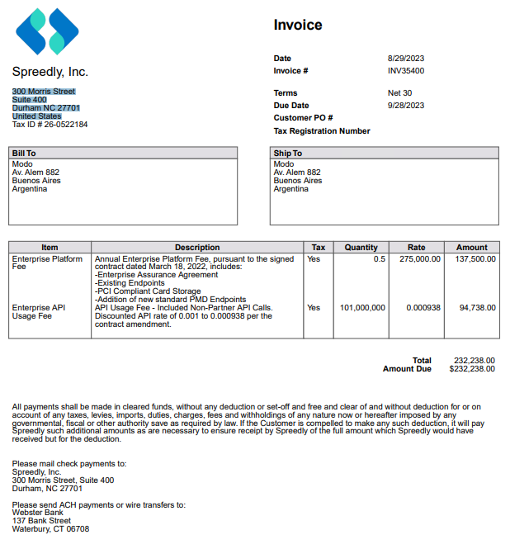

Exhibit B

Form of Notice of Assignment

[•], 2023

Messrs.

**Play Digital S.A.**

Dear Sirs,

We address you in our capacity as legal representatives of **Spreedly, Inc** (the “Company”), and in connection with the agreement entitled “Acuerdo de Pago” between **Play Digital S.A.**, as debtor, and the Company, as creditor, dated [date] (the “Payment Agreement”).

In connection therewith, we hereby notify you that we have assigned and transferred to Blasaca S.A.S., a corporation incorporated in Republica Oriental del Uruguay (the “Assignee”), as of the date hereof, all of our rights to the amount of [letras] [•], due and payable by the Account Debtor to the Assignor as described in said Payment Agreement (the “Receivables”).

We request that you take proper notice of such assignment and transfer and carry out all necessary actions for the prompt payment of the Receivables to the Assignee.

Sincerely,

**Spreedly, Inc**

By:   
[•]

By:   
[•]

Accepted and acknowledged this on [•], 2023**Play Digital S.A.**

By: Name:

Title: